Practical - 1
Practical Title: Project Initiation, Requirement Analysis, Sitemap, Wireframe, and GitHub Setup

Problem Definition: Initiate the semester-long StudentHub portal by identifying the problem scope, user roles, key modules, navigation flow, and minimum 10 pages. Create a sitemap, low-fidelity wireframe, project folder structure, README file, and GitHub repository.

Theory

What is URL and parts of URL?
- Answer: A URL (Uniform Resource Locator) is a unique web address used to identify and access resources available on the internet. It helps users locate web pages, files, and online services through a browser. It contains parts such as protocol, domain name, and path.
- Source:Geeksforgeeks

How does HTML file process in web browser?
Answer: When the user navigates to a new web page (by clicking a link, or entering a web address in the browser address bar)loading html file, several HTTP requests are sent, and several files are sent back in HTTP responses. The files received in these responses are processed by the browser and put together into a web page that the user can interact with.
Source: MDN Web Docs

3. How will page navigation flow managed among all HTML pages?
Answer: We use Sitemap which help us understand page navigation of all HTML pages
Source:W3School

4. How will GitHub commits be maintained after each practical?
Answer: After Each Practical ,I will commit my that practical to github into main branch.
Source:Geeksforgeeks

Implementation/ Output/Result
In this practical, I learned how to plan and structure a web project before diving into development. I created a sitemap to visually map out the pages of the website and how they connect to each other, which helped clarify the overall navigation flow. I then designed a low-fidelity wireframe to sketch the basic layout of each page — focusing on content placement and structure rather than visual design, which made it easier to plan the UI before writing any code. I also learned how to organize a project folder structure, separating files logically (like HTML, CSS, JS, and extra anything) to keep the project clean and easy to maintain. Additionally, I understood the importance of writing a clear README file, which documents the project's purpose, setup instructions, and folder structure for anyone viewing the repository. Finally, I learned how to create and manage a GitHub repository, including initializing it, committing changes, and pushing code, which helps in version control and makes the project accessible and shareable online.

Evidence of Work (Screenshots)
Wireframes:
1)Home Page:
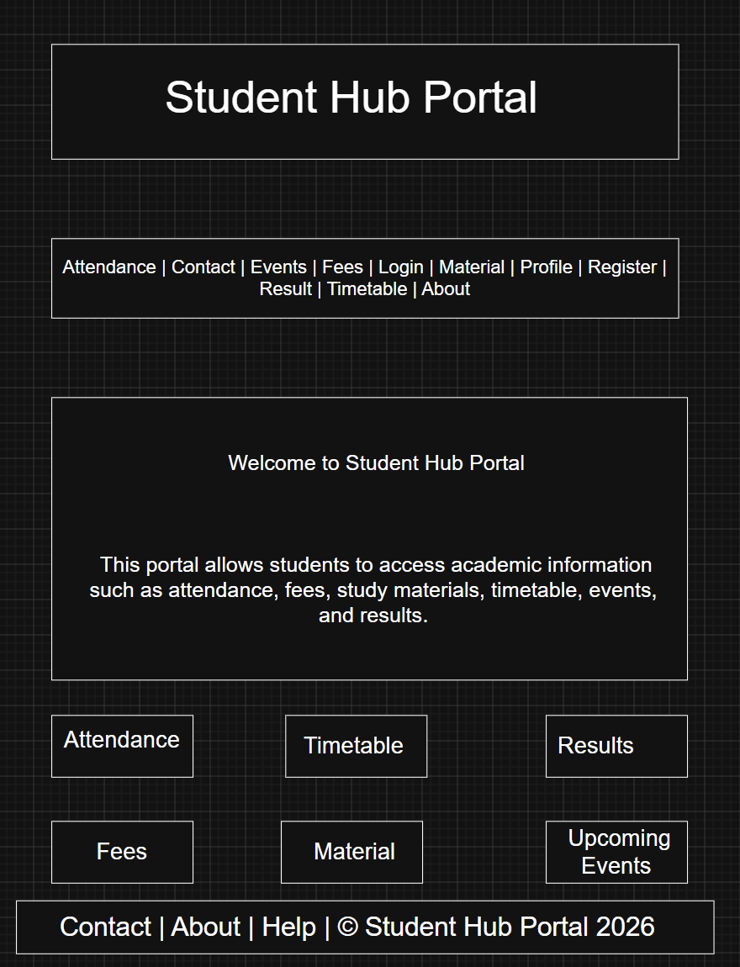
2)Login Page:
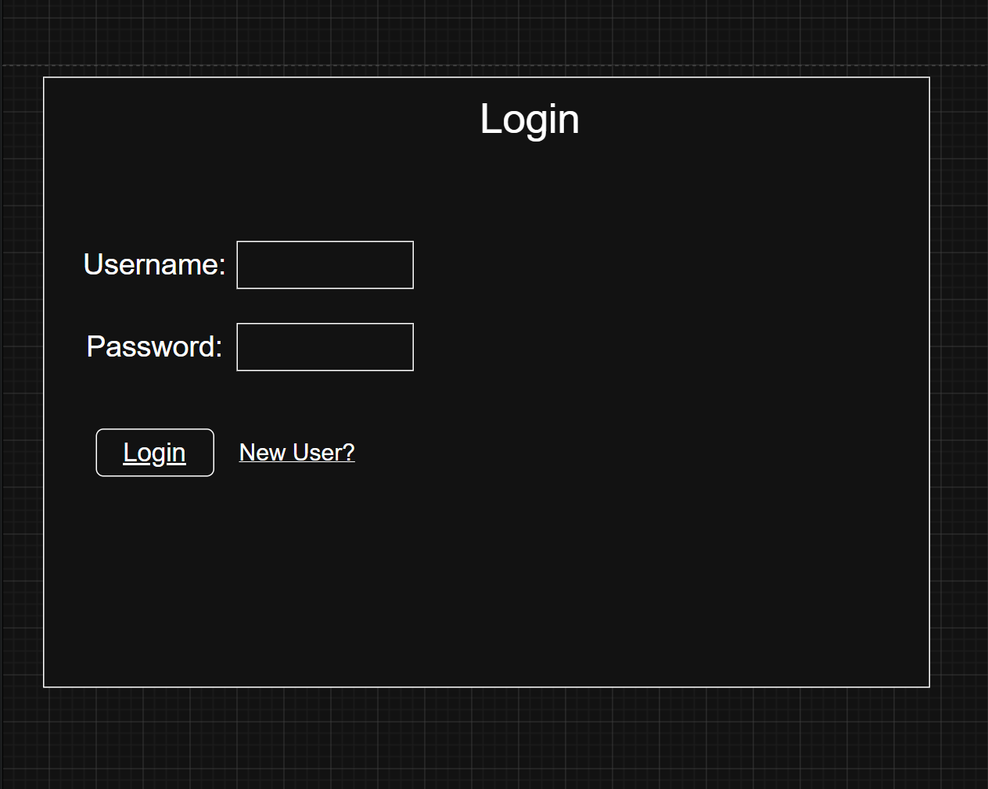
3)Register Page:
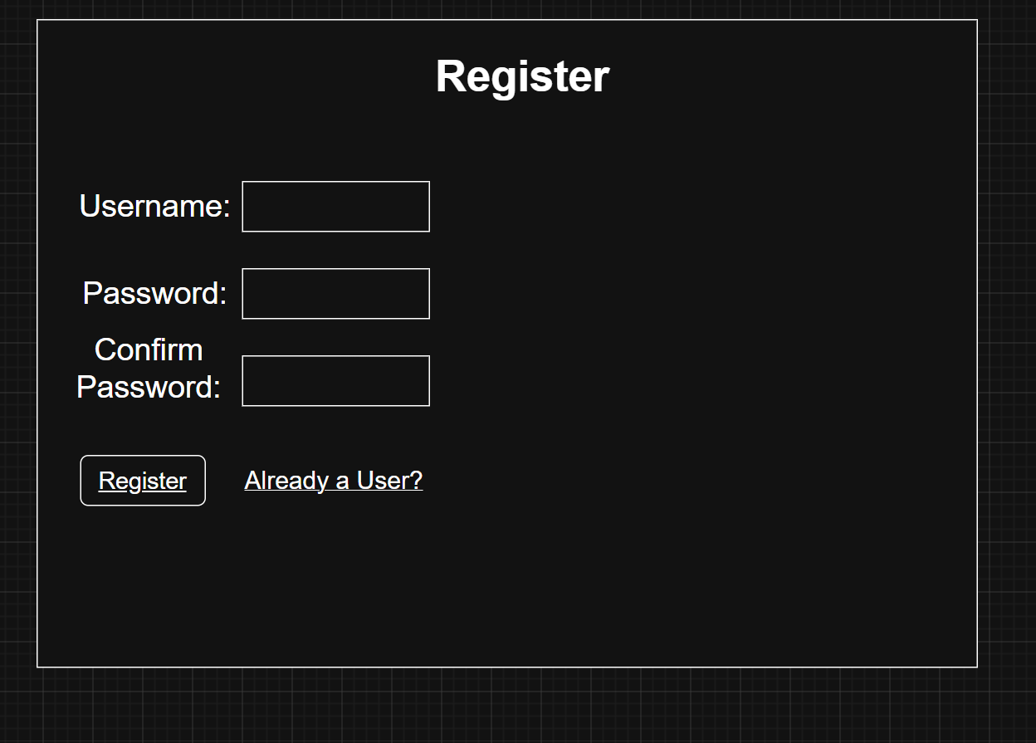

4)Attendance Page:
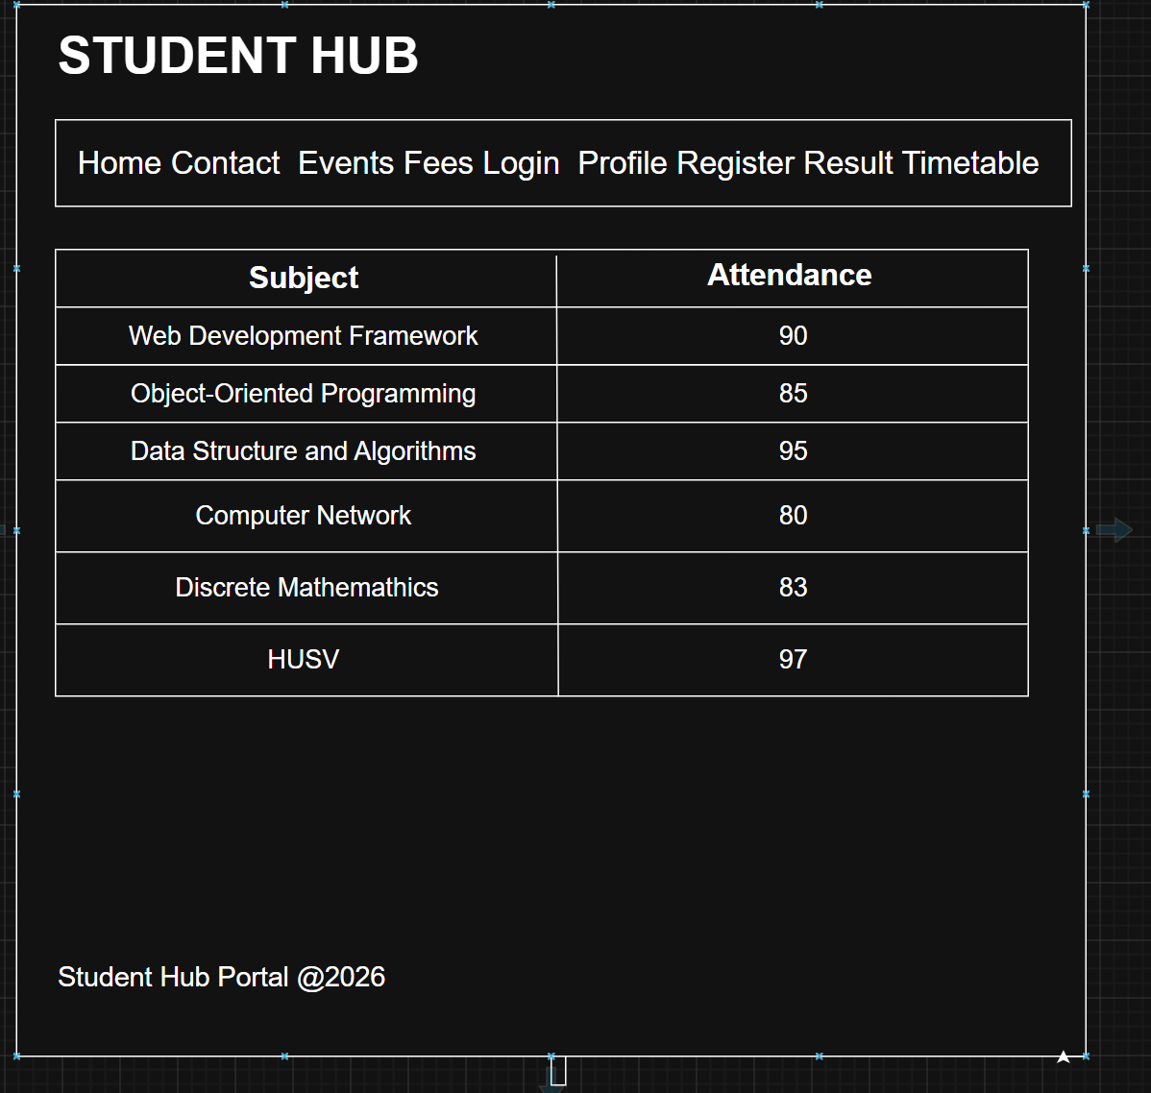
5)Contact Page:
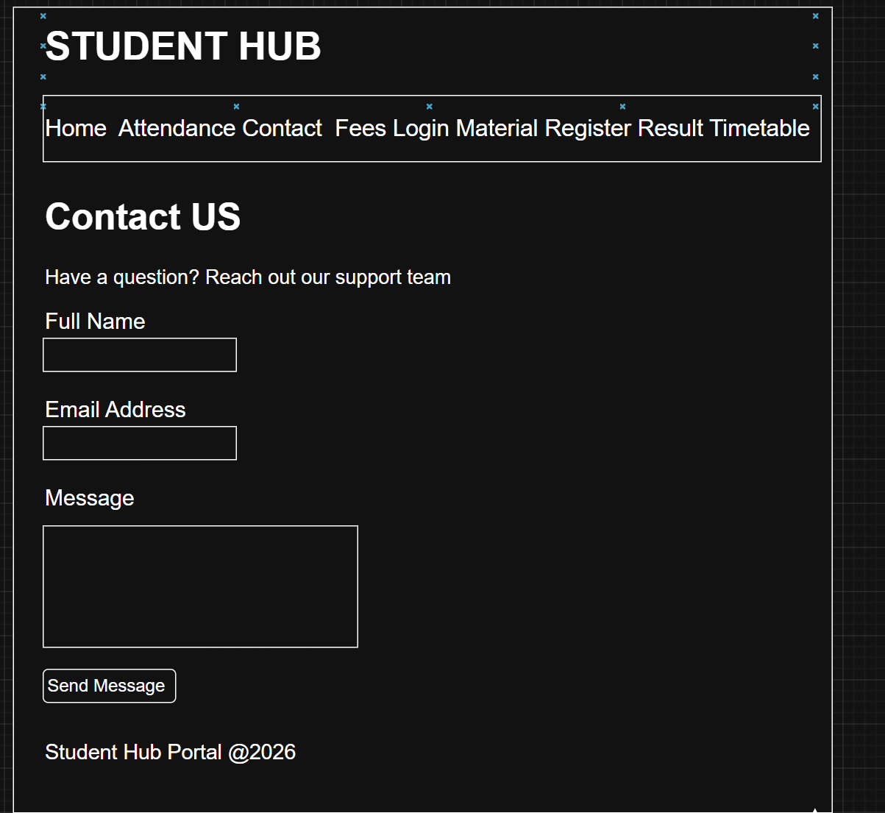

6)Details(Event) Page:
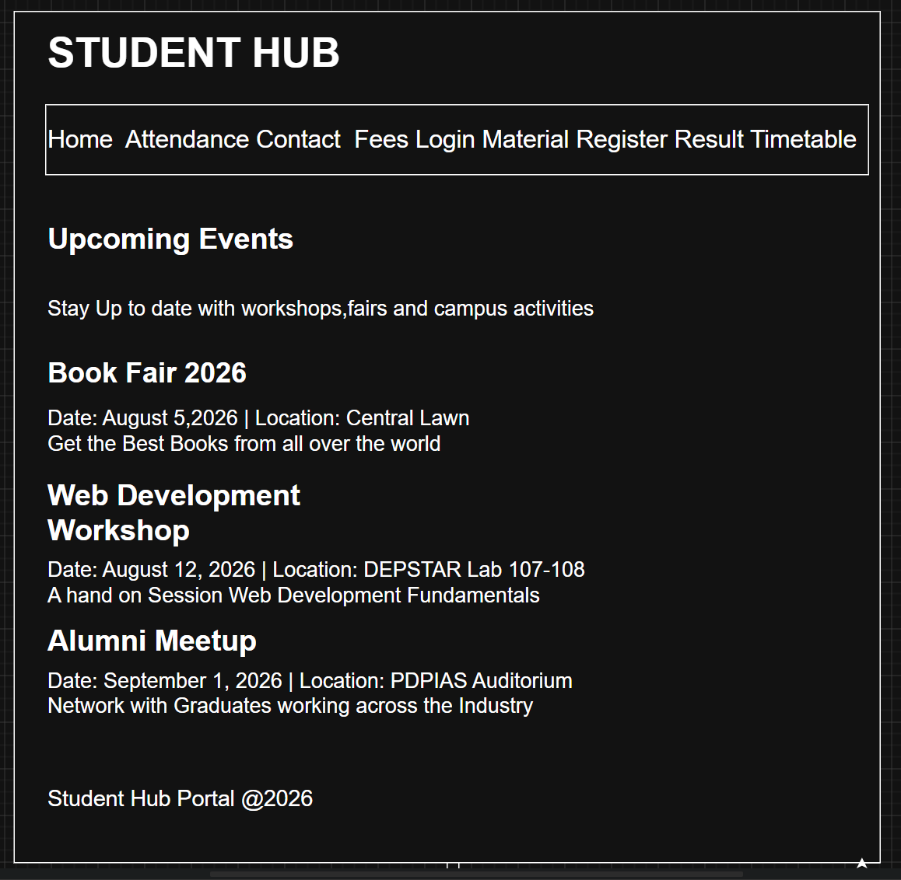
7)Fees Page:
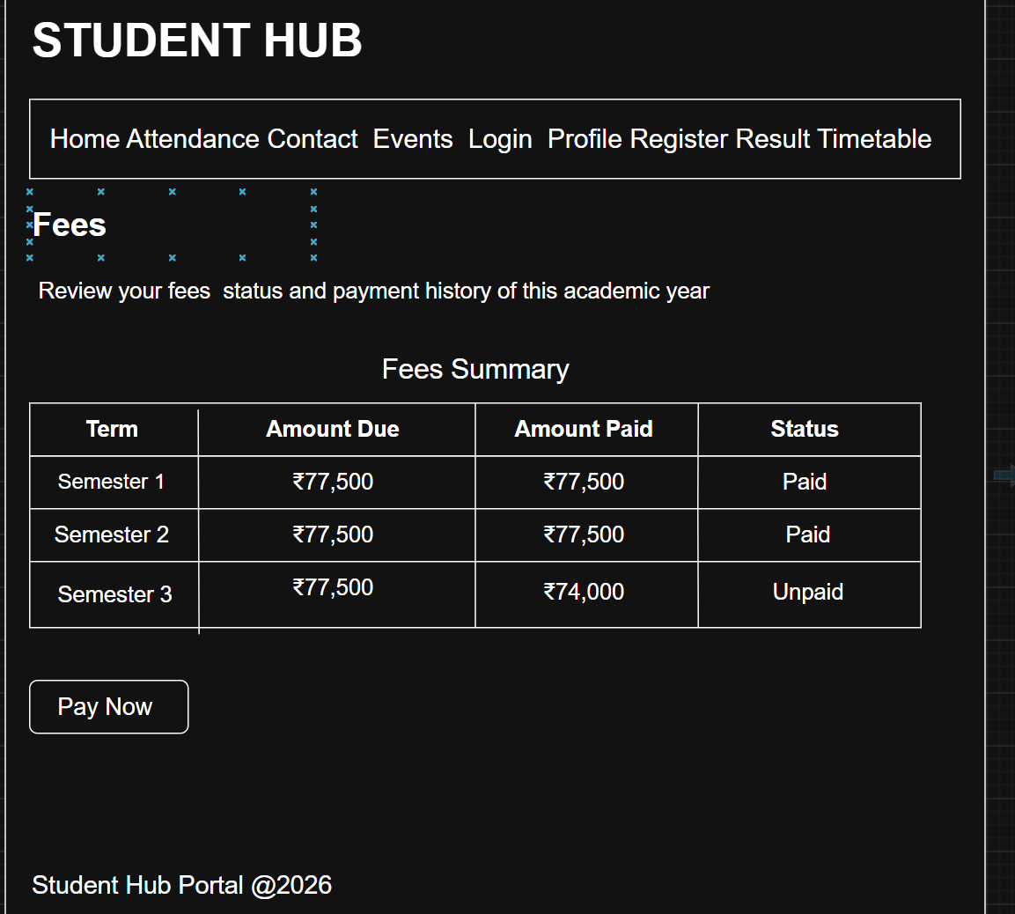

8)Material Page:
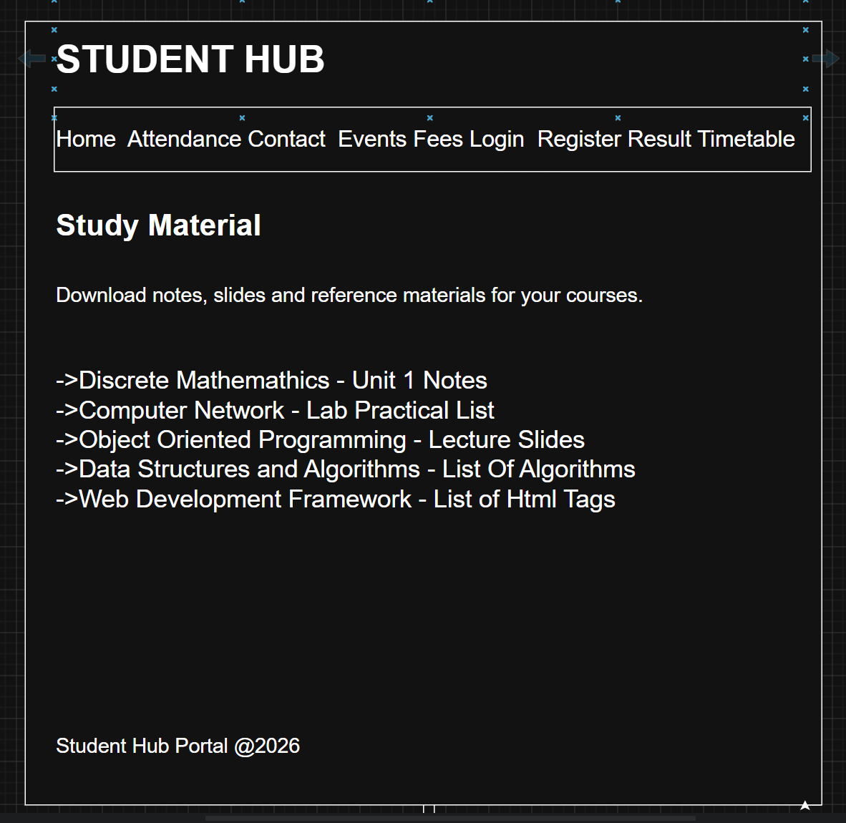

9)Profile Page:
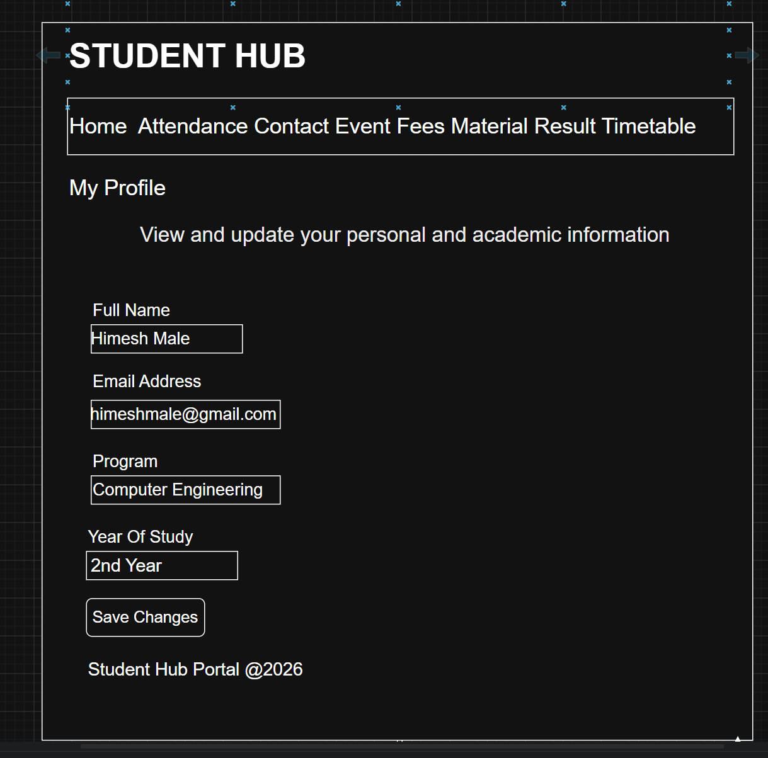
10)Timetable Page:
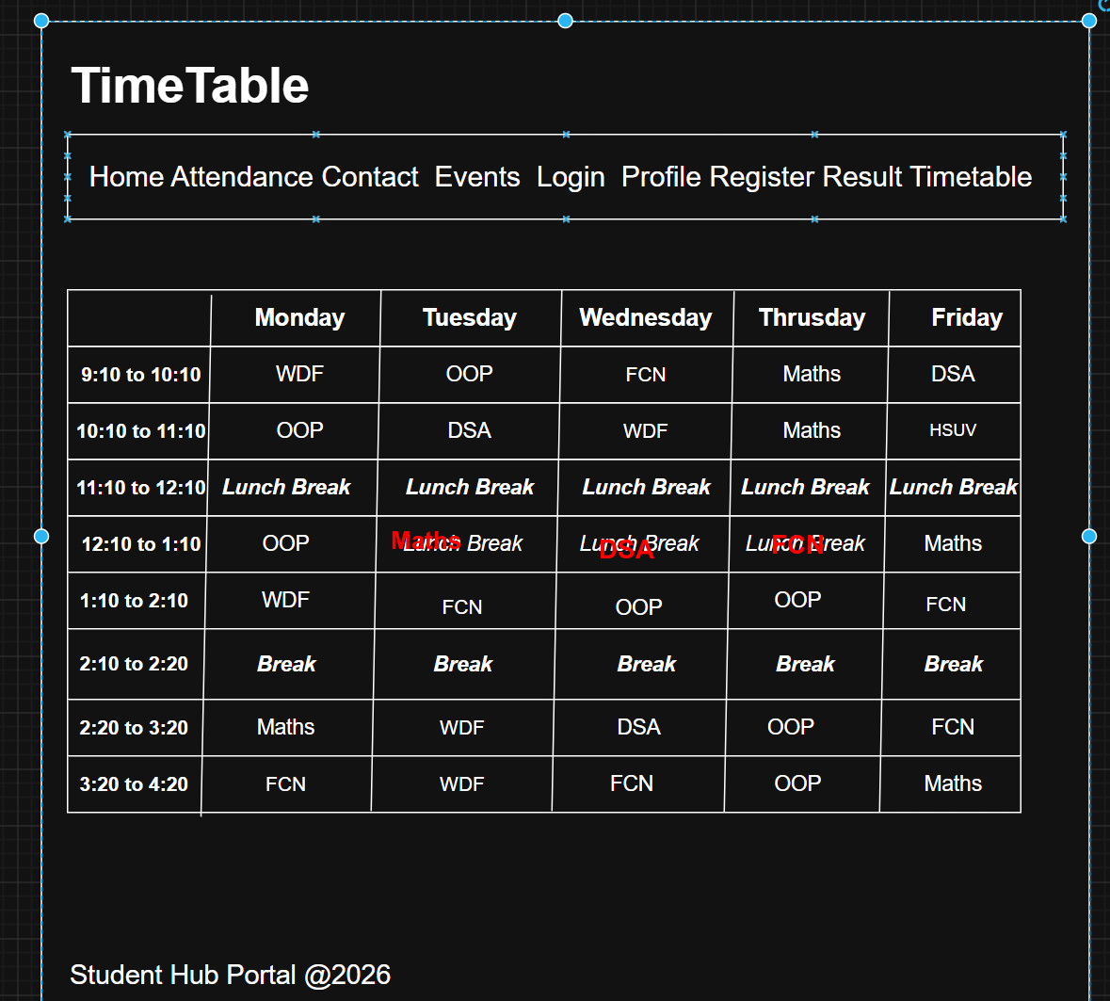

GitHub Repository Link: https://github.com/HimeshMale/Student-Hub-Portal.git

Challenges Faced:
I found it difficult to finalize the scope and decide how many pages and user roles were actually needed without over-complicating. Structuring the sitemap and wireframe in a logical flow also took a few attempts to get right.

Learning Outcomes:
I learnt how to break down a big project idea into clear modules, how wireframe and navigation flow(sitemap) are made before coding. I also understood how to set up a proper GitHub repository with a README for maintaining project structure.

Faculty Remarks:

